Uncover Hidden Threats, Reconstruct Attack Timelines, and Neutralize Sophisticated Cyber Vectors.


When a security incident strikes, traditional security tools often miss the footprints left behind by sophisticated threat actors. Modern attackers frequently leverage fileless malware, rootkits, and anti-forensic techniques to hide their tracks.
Trace Network’s Digital Forensics: Disk & Memory Forensics services provide a deep, surgical investigation into your systems, extracting concrete evidence from both non-volatile storage and volatile runtime memory to pinpoint exactly how, when, and where a breach occurred.

What We Do
We go beyond superficial log analysis. Our certified digital forensics experts perform exhaustive post-incident investigations, capturing and analyzing deep-system artifacts to reconstruct the entire lifecycle of an attack. By looking at both the hard drive (Disk) and the active system memory (RAM), we expose hidden adversaries and provide you with actionable intelligence to completely eradicate the threat.
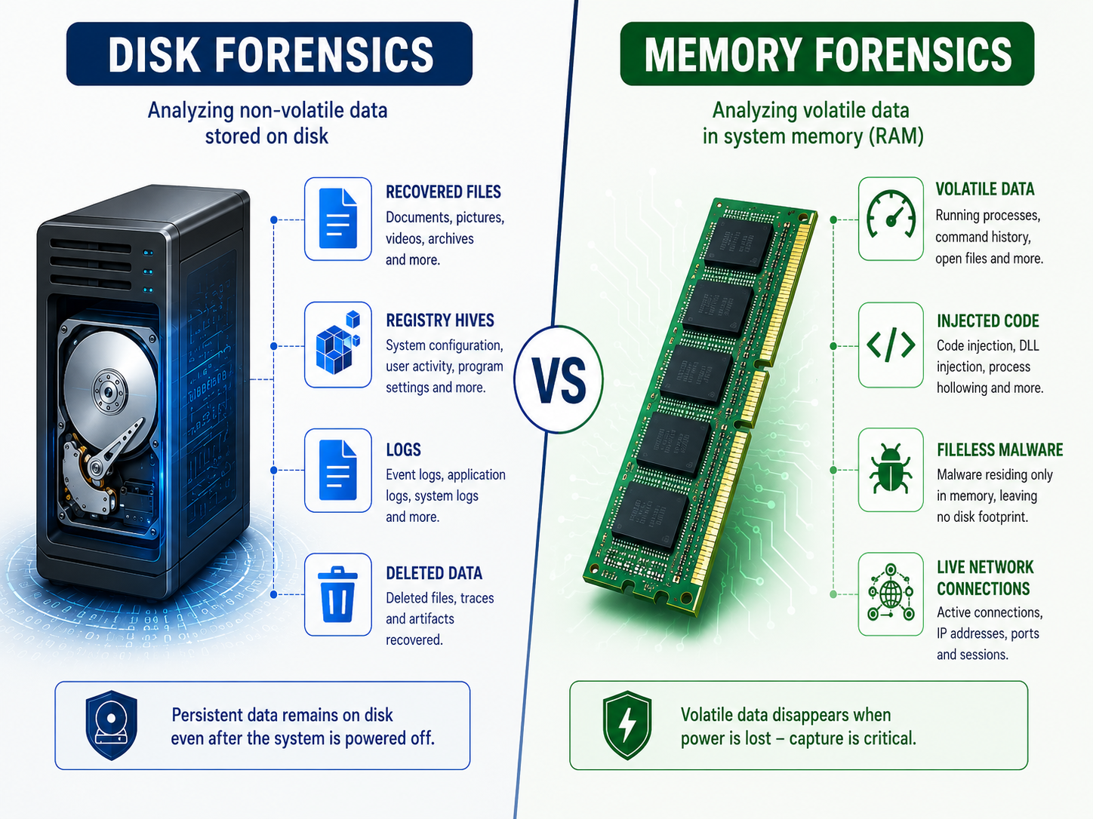
- Disk Forensics: Extracting, preserving, and analyzing non-volatile data from hard drives, solid-state drives, and server volumes. We reconstruct user activity, trace lateral movement, uncover unauthorized data exfiltration, and recover deleted or altered system files.
- Memory Forensics: Analyzing volatile data (RAM) captured while the system is running. This allows us to intercept fileless malware, discover active network connections, extract encryption keys, and identify injected code or rogue processes that vanish the moment a machine is powered down.

Why Advanced Forensics Matters
When your organization is hit by ransomware, an insider threat, or an Advanced Persistent Threat (APT), time is your greatest enemy. Standard incident response might stop an active alarm, but deep forensics answers the critical compliance and survival questions:
- What specific data was accessed or exfiltrated?
- How did the attacker gain initial entry?
- Are there hidden backdoors or persistence mechanisms left behind?

Our Proven 4-Step Forensic Methodology
We maintain strict industry-standard preservation protocols to ensure all evidence remains tamper-proof, court-admissible, and aligned with global information security standards.
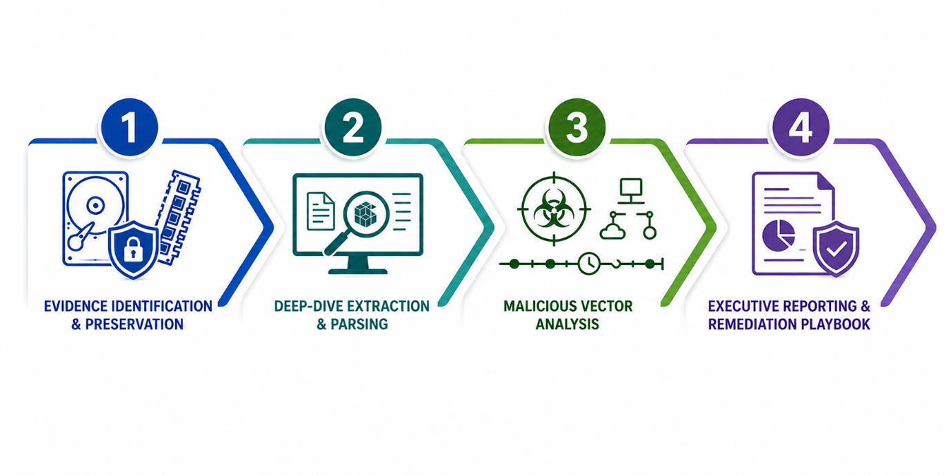
- Evidence Identification & Preservation We safely capture forensic images of disks and volatile memory dumps using write-blockers and cryptographic hashing, ensuring absolute integrity and a flawless chain of custody.
- Deep-Dive Extraction & Parsing Using advanced forensic suites, our team parses Master File Tables (MFT), system registries, event logs, and RAM dumps to isolate anomalies and indicators of compromise (IOCs).
- Malicious Vector Analysis We dissect malicious binaries, analyze command-and-control (C2) communication channels, and construct an exact timeline of the adversary's actions inside your network.
- Executive Reporting & Remediation Playbook We deliver an exhaustive, audit-ready technical report detailing the root cause, alongside a step-by-step remediation roadmap to ensure the threat cannot return.

Real-World Impact: Proven Private-Sector Expertise
We don't just rely on theoretical frameworks; our methods are proven in the field under high-pressure scenarios.

Successfully deployed across 10+ major private-sector organizations. > Trace Network has successfully executed end-to-end disk and memory forensic investigations for over 10 prominent private-sector enterprises. In every engagement, our deep-dive analysis successfully isolated complex malicious vectors—including stealthy fileless execution, privileged account abuse, and hidden persistence mechanisms—helping our clients rapidly contain breaches, protect corporate reputations, and safely resume operations.

What You Receive
- Root-Cause Analysis Report: Clear documentation explaining the exact entry point and execution path of the threat actor.
- Malicious Vector Map: A comprehensive breakdown of the binaries, scripts, or commands used during the breach.
- Evidence Retention Package: Cryptographically signed copies of forensic data preserved securely for compliance, legal, or insurance requirements.
- Hardening Roadmap: Tailored recommendations to patch identified gaps and elevate your enterprise network security posture.

Ready to Uncover the Truth?
Whether you are actively responding to a live incident or require a retrospective post-breach audit, our digital forensics team is ready to assist.
[Get a Free Expert Consultation] or Email us at connect@tracenetwork.in

